|  |  |
| --- | --- |
| Nama | : La Ode Muhammad Gazali |
| NIM | : 222212696 |
| Kelas | : 2KS2 |

**MODUL 14 PEMROGRAMAN BERORIENTASI OBJEK**

**(Networking Bagian 2)**

**Penugasan**

Laporkan hasil praktikum berikut dengan hasil penugasan dan penjelasannya ke Dosen dalam bentuk file pdf dengan format nama <<nim>>_modul14.

1. Lengkapi kode semua objek
2. Tangkapan layar hasil kode yang dilengkapi
3. Tangkapan layar hasil running

**Penyelesaian**

Pada modul 14 ini kita akan mengembangkan kode pada modul 13 supaya Server dapat menerima koneksi dari banyak client dengan menerapkan concurrency. Selain itu, pesan yang dikirimkan antara client ke server adalah object dari kelas Pesan yang menerapkan interface Serializable. (Latihan Server saya ubah menjadi Latihan Server2)

Pada project Latihan Server, buatlah kelas baru bernama Pesan dengan kode sebagai berikut (**Pesan.java**)

/*

 * Click nbfs://nbhost/SystemFileSystem/Templates/Licenses/license-default.txt to change this license

 * Click nbfs://nbhost/SystemFileSystem/Templates/Classes/Class.java to edit this template

 */

package latihan.server.pkg2;

/**

 *

 * @author U53R

 */

import java.io.Serializable;

public class pesan implements Serializable{

    private String nama;

    private String pesan;

    public pesan(String nama, String pesan) {

        this.nama = nama;

        this.pesan = pesan;

    }

    @Override

    public String toString(){

        return "["+nama+"] "+ pesan;

    }

    /**

    * @return the nama

    */

    public String getNama() {

        return nama;

    }

    /**

    * @param nama the nama to set

    */

    public void setNama(String nama) {

        this.nama = nama;

    }

    /**

    * @return the pesan

    */

    public String getPesan() {

        return pesan;

    }

    /**

    * @param pesan the pesan to set

    */

    public void setPesan(String pesan) {

        this.pesan = pesan;

    }

}

Kemudian modifikasilah **LatihanClient.java** menyesuaikan kode berikut ini

/*

 * Click nbfs://nbhost/SystemFileSystem/Templates/Licenses/license-default.txt to change this license

 * Click nbfs://nbhost/SystemFileSystem/Templates/Classes/Class.java to edit this template

 */

package latihan.server.pkg2;

/**

 *

 * @author U53R

 */

import java.io.BufferedOutputStream;

import java.io.BufferedReader;

import java.io.IOException;

import java.io.InputStreamReader;

import java.io.ObjectOutputStream;

import java.io.PrintWriter;

import java.net.Socket;

import java.util.logging.Level;

import java.util.logging.Logger;

public class LatihanClient {

    public static void main(String args[]){

        String hostName = "localhost";

        int portNumber = 4444;

        try (

            Socket echoSocket = new Socket(hostName, portNumber);

            BufferedOutputStream bos = new BufferedOutputStream(echoSocket.getOutputStream());

            ObjectOutputStream oos = new ObjectOutputStream(bos);

            BufferedReader in = new BufferedReader(new InputStreamReader(echoSocket.getInputStream()));

            BufferedReader stdIn = new BufferedReader(new InputStreamReader(System.in));){

            String msg;

            while((msg = stdIn.readLine()) != null){

                oos.writeObject(new pesan("Andi", msg));

                oos.flush();

                System.out.println("Client receive: "+ in.readLine());

                if(msg.equalsIgnoreCase("exit")) break;

            }

        }catch (IOException ex) {

            Logger.getLogger(LatihanClient.class.getName()).log(Level.SEVERE,null, ex);

        }

    }

}

Kemudian modifikasilah **LatihanServer2.java** menyesuaikan kode di bawah ini

/*

 * Click nbfs://nbhost/SystemFileSystem/Templates/Licenses/license-default.txt to change this license

 * Click nbfs://nbhost/SystemFileSystem/Templates/Classes/Main.java to edit this template

 */

package latihan.server.pkg2;

import java.io.BufferedInputStream;

import java.io.IOException;

import java.io.ObjectInputStream;

import java.io.PrintWriter;

import java.net.ServerSocket;

import java.net.Socket;

import java.util.logging.Level;

import java.util.logging.Logger;

/**

 *

 * @author U53R

 */

public class LatihanServer2 {

   /**

    * @param args the command line arguments

    */

    public static void main(String[] args) {

        // TODO code application logic here

        int portNumber = 4444;

        try (

            ServerSocket serverSocket = new ServerSocket(portNumber);

            Socket clientSocket = serverSocket.accept();

            PrintWriter out = new PrintWriter(clientSocket.getOutputStream(), true);

            BufferedInputStream bis = new BufferedInputStream(clientSocket.getInputStream());

            ObjectInputStream ois = new ObjectInputStream(bis);

        )

        {

            pesan pesan;

            while((pesan = (pesan) ois.readObject())!=null){

                System.out.println("Server Receive: " +

                pesan.toString());

                out.println("Pesan Diterima");

                if(pesan.getPesan().equalsIgnoreCase("exit"))

                    break;

            }

        } catch (IOException ex) {

            Logger.getLogger(LatihanServer2.class.getName()).log(Level.SEVERE, null, ex);

        } catch (ClassNotFoundException ex) {

            Logger.getLogger(LatihanServer2.class.getName()).log(Level.SEVERE, null, ex);

        }

    }

}

Kemudian jalankan LatihanServer2.java kemudian setelah itu jalankan LatihanClient.java. kita sudah menerapkan object serialization pada pertukaran pesan client dan server. Pesan yang ditukarkan berupa object dari kelas Pesan.

**Client(Andi) mengirimkan pesan ke server**

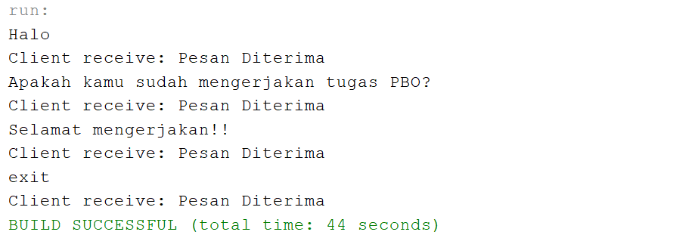

**Server menerima pesan dari client(Andi)**

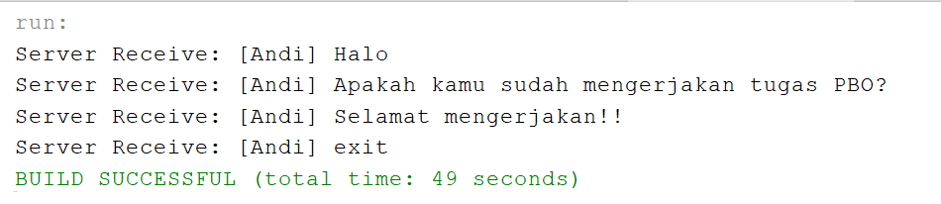

Supaya server dapat menerima banyak client, maka kita perlu melakukan penyesuaian. Pertama tambahkan new Class bernama **ServerThread.java** sebagai berikut

/*

 * Click nbfs://nbhost/SystemFileSystem/Templates/Licenses/license-default.txt to change this license

 * Click nbfs://nbhost/SystemFileSystem/Templates/Classes/Class.java to edit this template

 */

package latihan.server.pkg2;

/**

 *

 * @author U53R

 */

import java.io.BufferedInputStream;

import java.io.IOException;

import java.io.ObjectInputStream;

import java.io.PrintWriter;

import java.net.Socket;

import java.util.logging.Level;

import java.util.logging.Logger;

public class ServerThread extends Thread{

    private Socket clientSocket = null;

    public ServerThread(Socket clientSocket) {

        super();

        this.clientSocket = clientSocket;

    }

    @Override

    public void run(){

        try (

            PrintWriter out = new

            PrintWriter(clientSocket.getOutputStream(), true);

            BufferedInputStream bis = new

            BufferedInputStream(clientSocket.getInputStream());

            ObjectInputStream ois = new ObjectInputStream(bis);){

                pesan pesan;

                while((pesan = (pesan) ois.readObject())!=null){

                    System.out.println("Server Receive: " + pesan.toString());

                    out.println("Pesan Diterima");

                    if(pesan.getPesan().equalsIgnoreCase("exit"))

                        break;

                }

        } catch (IOException ex) {

            Logger.getLogger(ServerThread.class.getName()).log(Level.SEVERE,null, ex);

        } catch (ClassNotFoundException ex) {

            Logger.getLogger(ServerThread.class.getName()).log(Level.SEVERE,null, ex);

        } finally {

            if(clientSocket!=null){

                try {

                    clientSocket.close();

                } catch (IOException ex) {

                    Logger.getLogger(ServerThread.class.getName()).log(Level.SEVERE,null, ex);

                }

            }

        }

    }

}

Kemudian modifikasi **LatihanServer2.java** sebagai berikut:

/*

 * Click nbfs://nbhost/SystemFileSystem/Templates/Licenses/license-default.txt to change this license

 * Click nbfs://nbhost/SystemFileSystem/Templates/Classes/Main.java to edit this template

 */

package latihan.server.pkg2;

import java.io.BufferedInputStream;

import java.io.IOException;

import java.io.ObjectInputStream;

import java.io.PrintWriter;

import java.net.ServerSocket;

import java.net.Socket;

import java.util.logging.Level;

import java.util.logging.Logger;

/**

 *

 * @author U53R

 */

public class LatihanServer2 {

   /**

    * @param args the command line arguments

    */

   public static void main(String[] args) {

        // TODO code application logic here

        int portNumber = 4444;

        boolean listening = true;

        try (

            ServerSocket serverSocket = new

            ServerSocket(portNumber);){

                while(listening){

                    Socket clientSocket = serverSocket.accept();

                    new ServerThread(clientSocket).start();

                }

        } catch (IOException ex) {

            Logger.getLogger(LatihanServer2.class.getName()).log(Level.SEVERE, null, ex);

        }

    }

}

Tidak ada perubahan pada kode LatihanClient.java namun ketika mau melakukan run file LatihanClient yang kedua, ubahlah nama Andi menjadi Budi supaya nama pengirimnya berbeda.

Jalankan LatihanServer.java kemudian Jalankan LatihanClient.java dengan nama LaOde, kemudian jalankan latihanClient.java dengan nama Gazali. Client akan berhenti jika mengetikkan exit sedangkan server masih akan terus menunggu client baru terkoneksi.

**Clien (LaOde) mengirim pesan ke server**

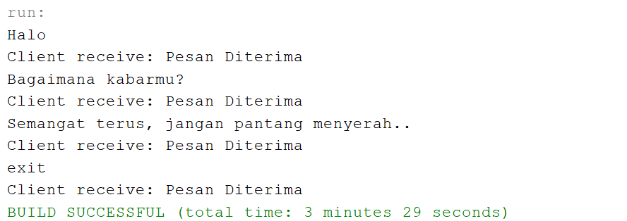

**Clien (Gazali) juga mengirim pesan ke server**

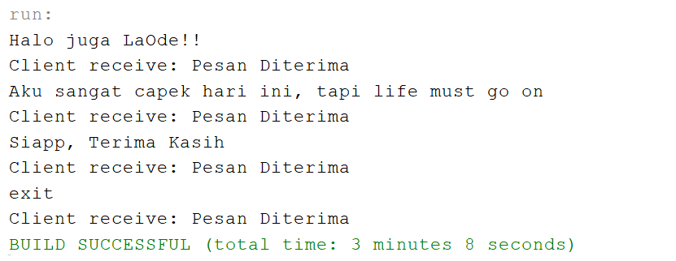

**Selanjutnya server menerima pesan kedua client tersebut**

